Sunho Biologics

# Overview

The company is a biopharmaceutical company specializing in the development of immunotherapies, particularly immunocytokines, for the treatment of cancers and autoimmune diseases. They have a strong pipeline of products, with six in clinical stage, and have obtained IND approvals for three immunocytokines.

The company has developed advanced immunocytokines for treating cancer patients. They have received IND approvals for conducting Phase I/II clinical trials and have shown promising results in preliminary anti-tumor activities.

# Our Business model

The company focuses on developing immunocytokines and immunotherapies for oncology and autoimmune diseases. They plan to collaborate with pharmaceutical companies and expand their international team to advance clinical studies and secure global registration for their products.

The company has R&D capabilities in immunocytokines, monoclonal antibodies, bispecific antibodies, and fusion proteins. Their Core Product IAH0968 showed promising results in Phase I clinical trials for metastatic biliary tract carcinoma and colorectal cancer. They are also developing six other product candidates, including IBB0979, which received IND approvals for clinical trials in B7H3-high expressing solid tumors.

The company has a diverse pipeline of potential therapies, including a dual-target therapy for immune response and candidates for oncology and autoimmune diseases. They have proprietary technology platforms to enhance drug development.

The company has developed multiple products based on different platforms and has GMP-compliant manufacturing facilities. The management team has extensive experience in R&D and clinical development.

# Financial Information

Here are screenshots which represent financial information.

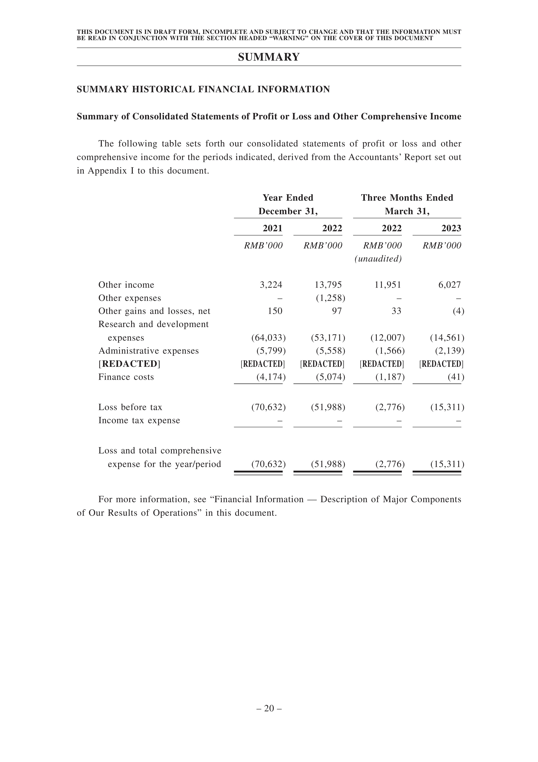

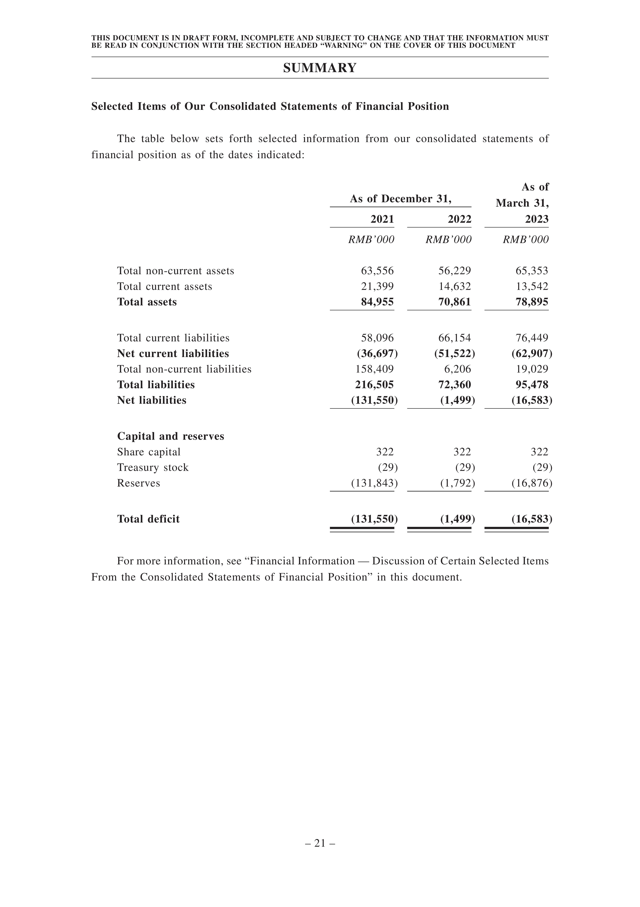

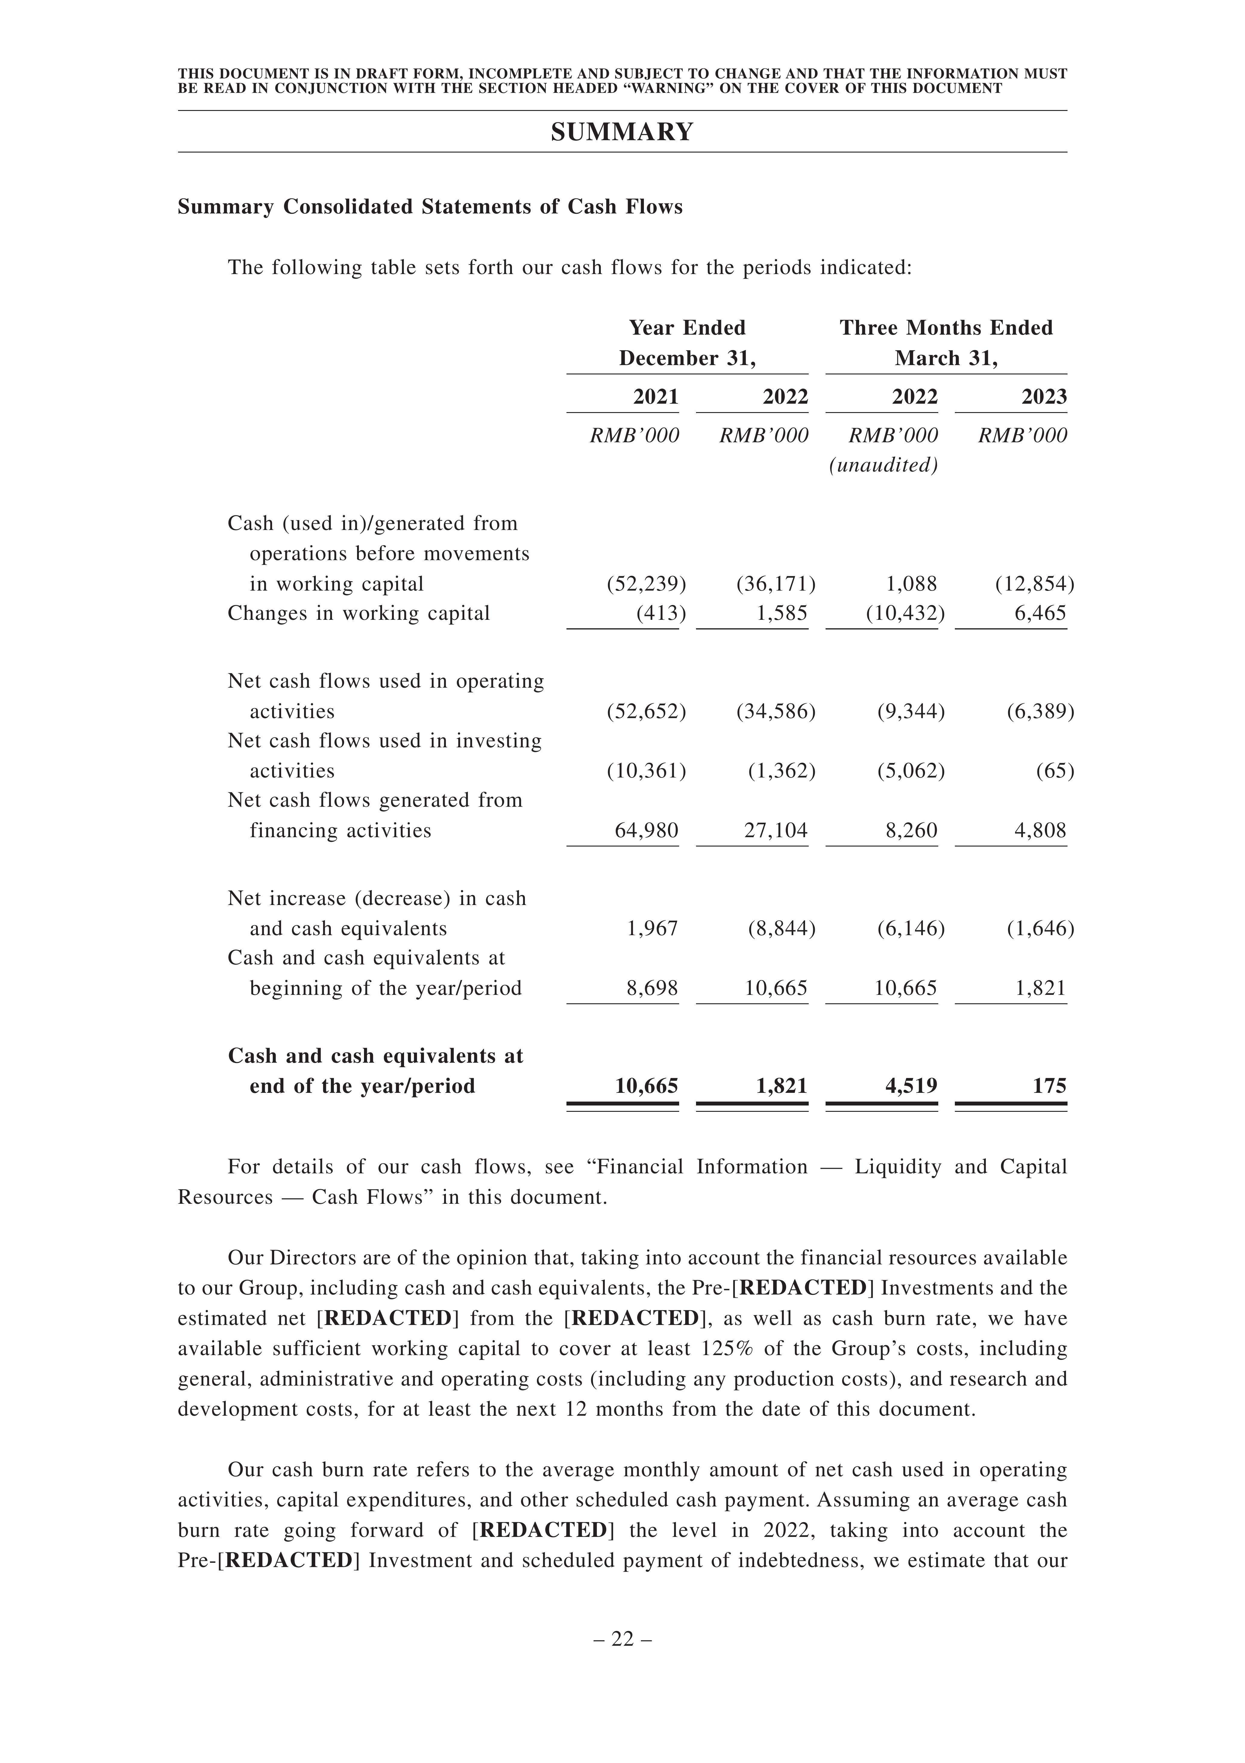

# Risk Factors

The review highlights various risks and uncertainties related to the company's drug candidates, including clinical development, regulatory approvals, and commercialization. The success of the business depends on these factors.  
  
- Obtaining necessary supplies and regulatory approvals, protecting intellectual property, and commercializing drug candidates.  
- Delays or difficulties in approvals and commercialization may impact revenue and overall business.  
- Lack of experience in regulatory approval and potential challenges in identifying new drug candidates.

The company's proprietary technology platforms may not guarantee success in identifying new drug candidates. Developing and manufacturing certain drug candidates may be challenging. Research programs require substantial resources and may not yield desired results. The company needs to invest in research and development to keep pace with the evolving biologics market.  
The company faces intense competition and risks of technological obsolescence. Competitors have greater resources and more advanced drug candidates. Mergers and acquisitions concentrate resources among fewer competitors. Clinical trials may encounter delays and unexpected difficulties.

The company faces risks such as developing risk evaluation measures, conducting post-market studies, and potential product recalls. Limited resources may hinder success and commercial potential. Data accuracy and regulatory compliance are also concerns.

The company faces potential risks from inadequate insurance coverage, reliance on third parties, and product liability.

The company faces potential product liability claims, decreased demand, and financial strain due to manufacturing issues.

The company faces risks such as product recalls, manufacturing changes, and shortages of personnel and materials. These risks could lead to delays, increased costs, and damage to the company's reputation. Interruptions in manufacturing operations could also impact clinical trials and commercialization efforts.

The company's manufacturing facilities are crucial to its business and any disruption could harm its operations and financial condition. Compliance with regulatory standards is essential and failure to do so may result in delays and penalties. FDA inspections can be challenging and costly.  
The company faces risks in meeting demand, scaling up production, and expanding manufacturing capacity.

The company needs to invest in marketing and sales to distribute products worldwide. Collaboration may be necessary, but success is not guaranteed. Market acceptance and competition are risks.  
- Market acceptance of drug candidates and competition may affect revenue and business.  
- Counterfeit products and illegal imports may impact demand and reputation.  
- Safety and efficacy issues with combination therapies may lead to regulatory delays or supply shortages.

Development risks are higher for investigational drugs. Regulatory requirements and potential supply shortages may cause delays. Guidelines and reimbursement policies can impact sales.  
Obtaining coverage and reimbursement for drugs is time-consuming and costly, impacting profitability. Reimbursement uncertainty and limited coverage pose risks.  
The company relies on patent protection for its technologies and drug candidates. Failure to obtain and maintain patents could harm the business.  
The company faces risks of patent breaches, challenges, and potential loss of exclusivity.  
  
The company has a total deficit and net current liabilities, which may impact liquidity. They have experienced net cash outflows from operating activities and may require additional financing.  
Financial assets at fair value through profit or loss pose risks to net changes in fair value. Share-based payment may dilute shareholding and negatively impact financial performance. Fluctuations in exchange rates may result in foreign currency exchange losses. Failure to comply with regulations and obtain necessary approvals could harm business and reputation.  
Failure to obtain or renew necessary approvals may result in enforcement actions and penalties. Loss of key management could adversely affect business. Difficulty attracting and retaining qualified employees.

The company faces intense competition in hiring and retaining key personnel, which may affect financials. Managing growth and hiring additional personnel is challenging. Acquisitions and partnerships may increase risks and capital requirements.  
The company faces risks related to acquisitions, integration, key personnel retention, and generating revenue from acquired technology. Additionally, natural disasters and global disruptions pose threats.

The company faces risks associated with global business, including political and regulatory changes, intellectual property protection, and economic instability.  
The company faces potential legal disputes and claims that could exceed insurance coverage. Labor costs and shortages may impact operations. Compliance with environmental laws is crucial.  
The company faces risks of contamination, accidents, compliance costs, reputational damage, and employee misconduct.

The company's operations may be affected by suboptimal supplies, non-compliance, and potential product liability claims. Collaboration efforts may not yield desired benefits.  
Collaboration partners may not pursue drug development, delay trials, or compete with our candidates.  
- 75.4%, 54.1%, and 76.1% of purchases from top 5 suppliers in 2021, 2022, and Q1 2023.  
- Reliance on top suppliers may lead to price increases or shortage of supplies.  
- Compliance with regulations and industry standards is crucial for reputation and business.  
- Complex and costly regulatory compliance burden in major markets like China and the US.  
- Potential impact of the "Executive Order" on biotechnology and biomanufacturing industries.  
- Clinical trials conducted in China, with plans for future development in the United States.

The company faces risks related to regulatory compliance, delays in clinical trials, and adverse events.  
- Regulatory authorities may withdraw approvals or revoke licenses for drug candidates.  
- Additional warnings may be required on the label of approved drug candidates.  
- Risk evaluation and mitigation strategies may need to be developed or updated.  
- Post-market studies may be required.  
- Litigation proceedings and liability for harm caused to subjects or patients.  
- Insufficient patient enrollment or dropouts may occur.  
- Clinical trial costs may be higher than anticipated.  
- Reputation may suffer.  
- FDA may not accept data from clinical trials conducted in China.  
- FDA requires certain conditions for acceptance of foreign clinical trial data.  
- Privacy laws and data protection regulations pose risks in managing medical data.

The company is subject to various data protection and privacy laws in China and the US.  
The company faces compliance risks with genetic resource regulations and privacy laws. Operational costs may increase due to data privacy requirements.  
The company faces risks related to patient data leakage, noncompliance with privacy laws, and regulatory requirements for technology import/export and genetics/data safety.  
The company's research and development may be hindered if they cannot obtain necessary approvals for sending scientific data abroad. Regulatory obligations and penalties may also affect business.  
The company faces risks from regulatory enforcement, potential legal violations, and compliance costs.  
Failure to comply with anti-bribery laws could result in severe penalties and business disruptions. Regulatory changes in the pharmaceutical industry may affect drug approval and commercialization. Economic, political, and legal developments in China can impact business operations. Laws and regulations related to the pharmaceutical industry evolve over time. The NMPA's drug approval system reform may affect the commercialization of drug candidates.  
The company review mentions potential adverse impacts of new regulations, trade policy changes, and offshore investment restrictions.  
  
Dividends paid by PRC subsidiaries may be subject to a 10% withholding tax. Non-PRC shareholders may face PRC withholding tax on dividends and gains from share transfers. Indirect transfers of PRC taxable assets may be subject to PRC EIT. Sale of shares on a public stock exchange is exempt from PRC EIT. Bulletin 7 may apply to sale of shares of offshore subsidiaries with PRC taxable assets, resulting in tax obligations. PRC tax authorities adjust taxable capital gains based on fair value of transferred assets.